Contents

Docker 1

Azure Kubernetes Service (AKS ) 1

# Container Product/Services

<https://azure.microsoft.com/en-in/product-categories/containers/>

## Find the Azure service for your container needs

|  |  |
| --- | --- |
| IF YOU WANT TO | USE THIS |
| Simplify the deployment, management and operations of Kubernetes | [Azure Kubernetes Service (AKS)](https://azure.microsoft.com/en-in/services/kubernetes-service/) |
| Quickly create powerful cloud apps for web and mobile | [App Service](https://azure.microsoft.com/en-in/services/app-service/) |
| Easily run containers on Azure without managing servers | [Container Instances](https://azure.microsoft.com/en-in/services/container-instances/) |
| Cloud-scale job scheduling and compute management | [Batch](https://azure.microsoft.com/en-in/services/batch/) |
| Develop microservices and orchestrate containers on Windows or Linux | [Service Fabric](https://azure.microsoft.com/en-in/services/service-fabric/) |
| Store and manage container images across all types of Azure deployments | [Container Registry](https://azure.microsoft.com/en-in/services/container-registry/) |
| Run fully managed OpenShift clusters, jointly operated with Red Hat | [Azure Red Hat OpenShift](https://azure.microsoft.com/en-in/services/openshift/) |

# Azure Container Instance

<https://www.youtube.com/watch?v=jAWLQFi4USk>

<https://www.youtube.com/watch?v=oTM3xDpTrBE>

# Container Image

<https://www.youtube.com/watch?v=Bc7FpteQSAk>

# Azure Container Registry

<https://www.youtube.com/playlist?list=PLpbcUe4chE7-4XhZurHEErjPqJzpGS5zp>

<https://github.com/HoussemDellai/azure-acr>

# Azure Kubernetes Service (AKS)

<https://docs.microsoft.com/en-us/azure/aks/intro-kubernetes>

<https://www.youtube.com/playlist?list=PLp_fsLj4v7gTA8n2UngXfOc_5puPPmFdK>

<https://www.youtube.com/playlist?list=PLfeid9nyFRy-arSxDJrq3-Rz5CP2OKJkr>

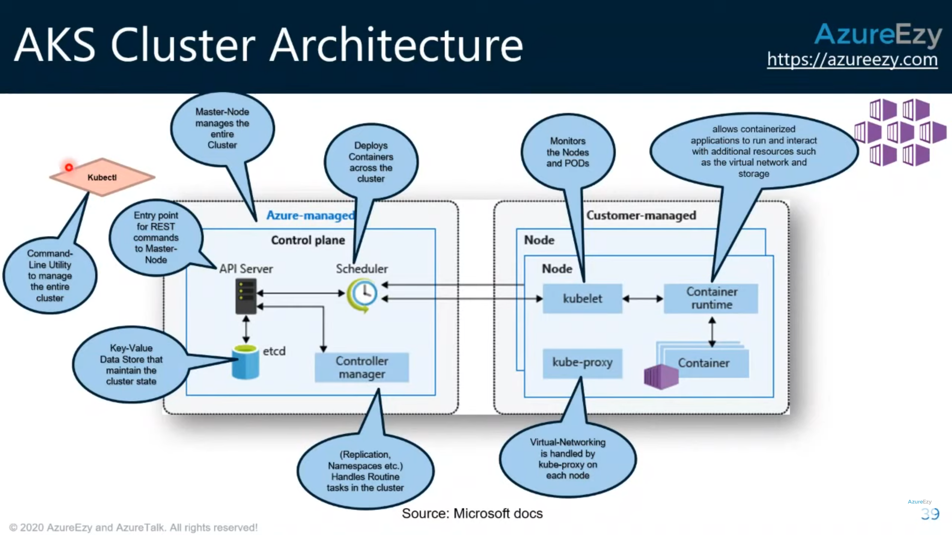

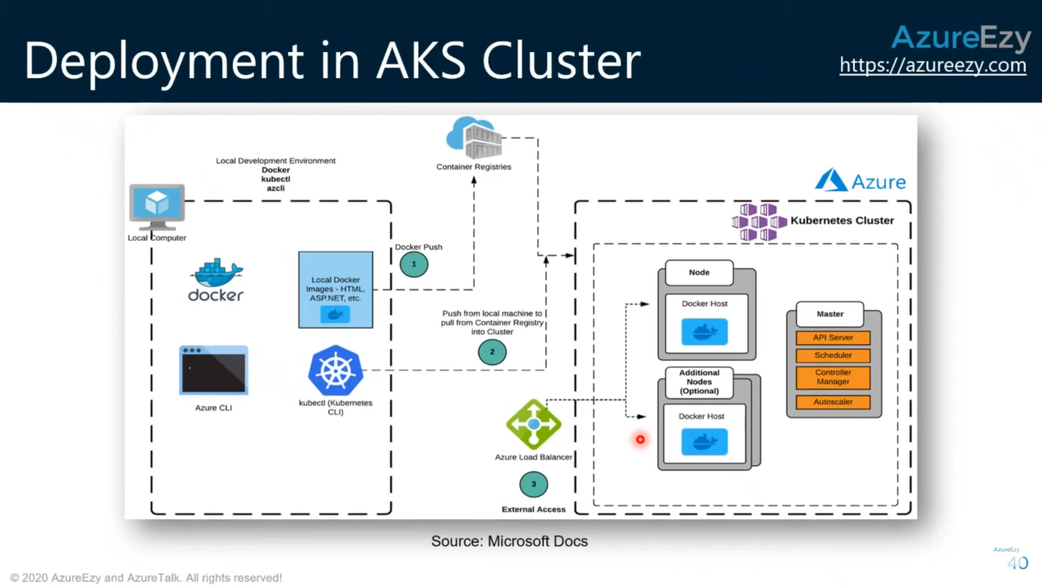

## Pods

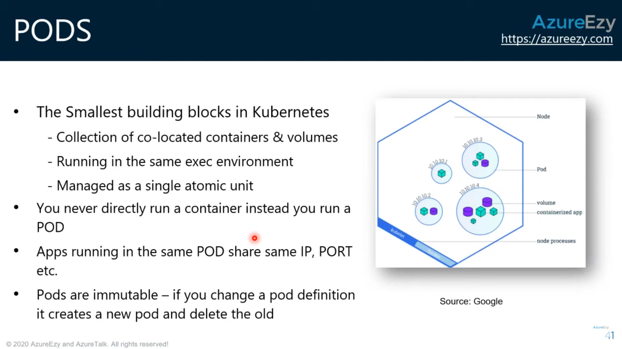

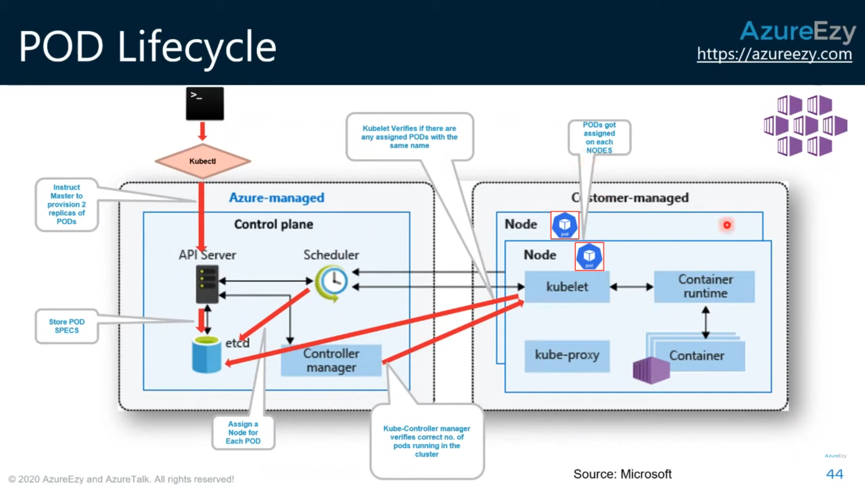

## Replica Sets

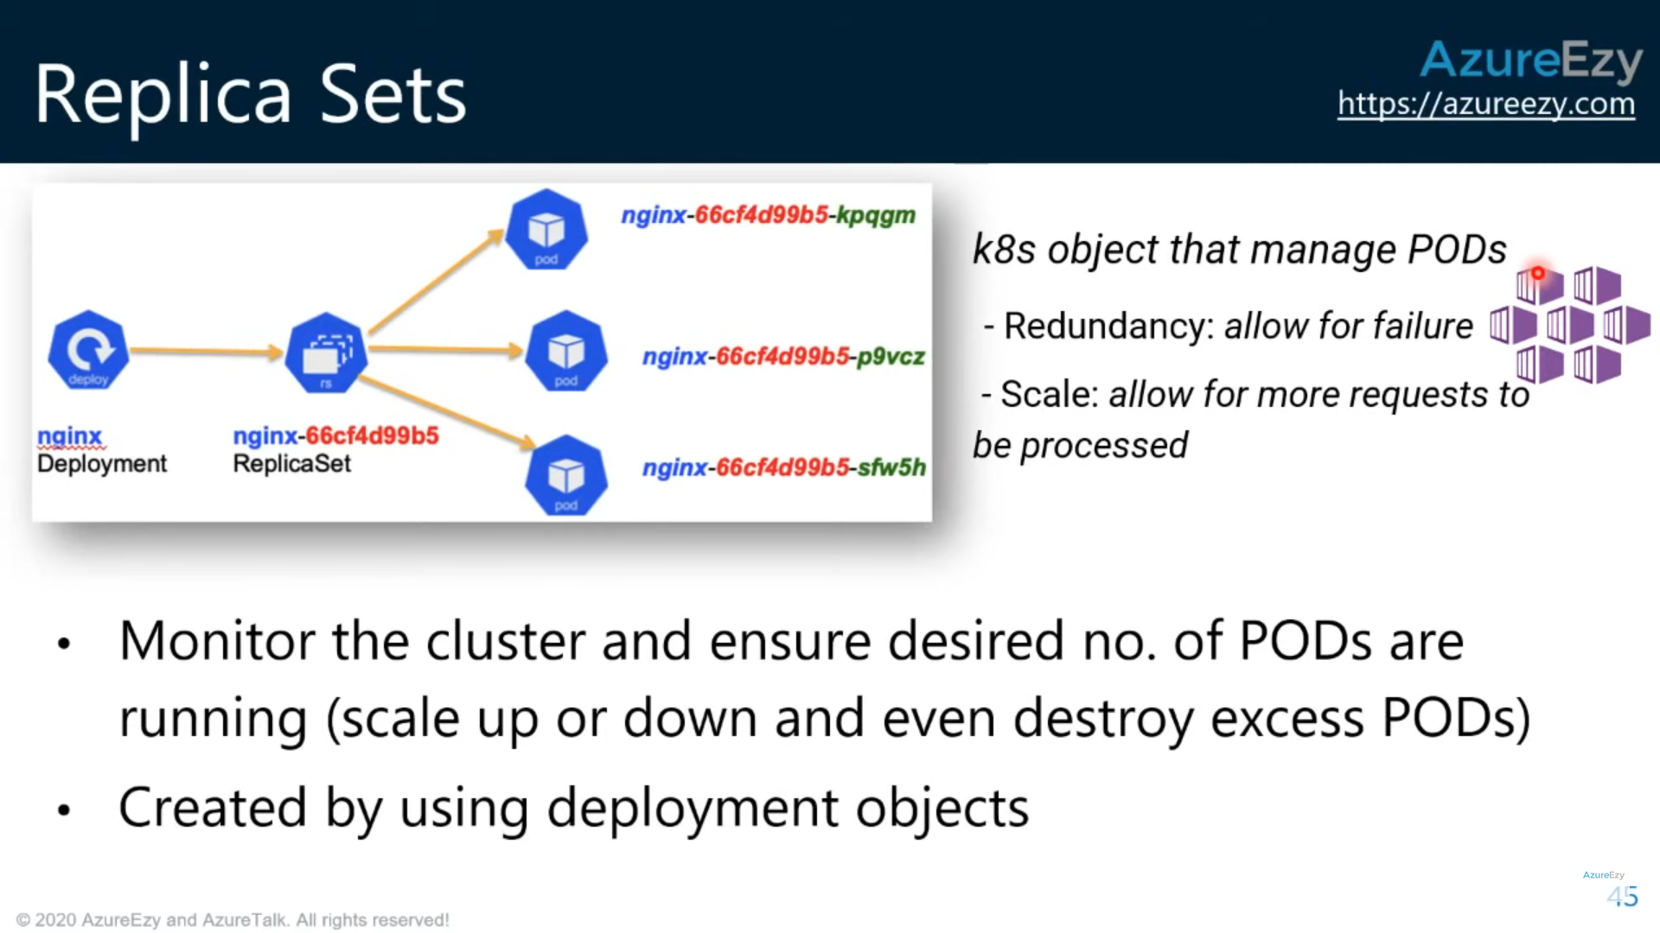

## Deployments

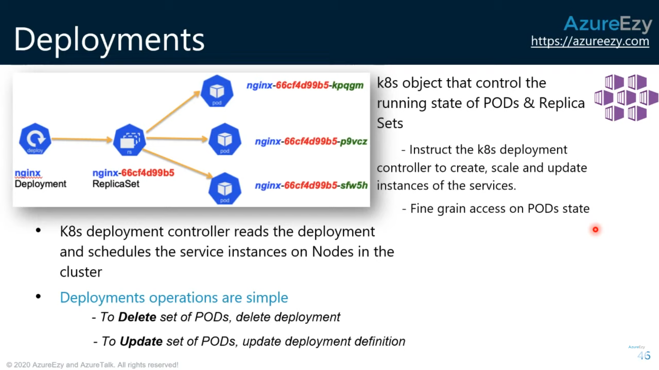

<https://github.com/CloudA2Z-Code/AZ_Azure_Webinars/blob/master/AZ_104_Webinar_Commands>

# Azure Monitor for containers overview

<https://docs.microsoft.com/en-us/azure/azure-monitor/insights/container-insights-overview>